Casper tool

* Architechture

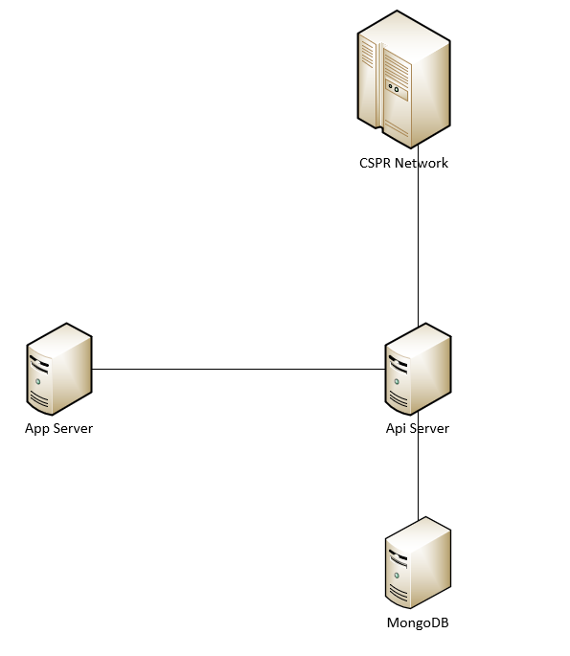

* + We use mongodb to store data that get from CSPR network with auto job.
  + Api server will implement some tasks:
    - Get data from CSPR by job
    - Create api REST for app server
  + Language:
    - Nodejs
    - Reactjs
* About our code in app server (Used for client):

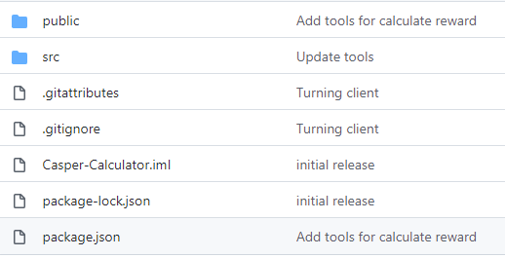

* + Public folder:
    - This is used for creating UI
    - CSS, font, images, js, … are created in this folder
  + Src folder:

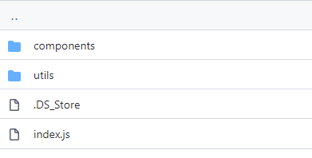

* + - Components:
      * Account component: UI for user’s account
      * App component: UI for main application
      * Contact component: UI for contact info
      * Home component: UI for home page
      * Nav component: UI for navigation bar
      * ValidatorInfo component: UI for validator’s info
    - Utils:
      * All functions can be used in this project
* About our code in api server (Used for app server):

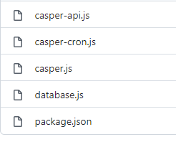

* + Databas.js: Connect to mongodb and CRUD data
  + Casper-cron.js: Jobs running on server
  + Casper-api.js: Api for client server
  + Casper.js: All funtions can be used in this project
* Preview our site:
  + URL: <https://blockshark.net/casper-profit-calculator/>
  + Home page:
    - We can see all network’s information:
      * Block Height
      * Current ERA
      * Total Node number
      * Total valid Validator Nodes
      * Total staked
      * Total circulation
      * Total CSPR
    - List of all active Validators
    - Estimation of Earnings by ERA, DAY, and MONTH from user Input Staked Amount

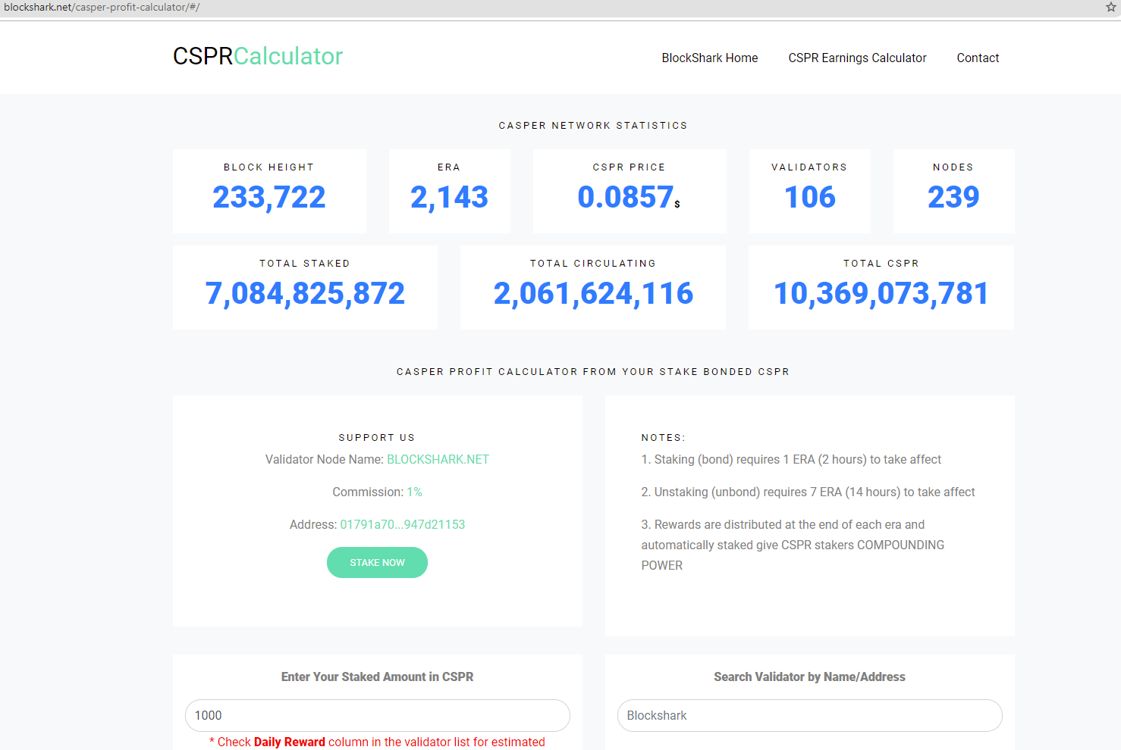

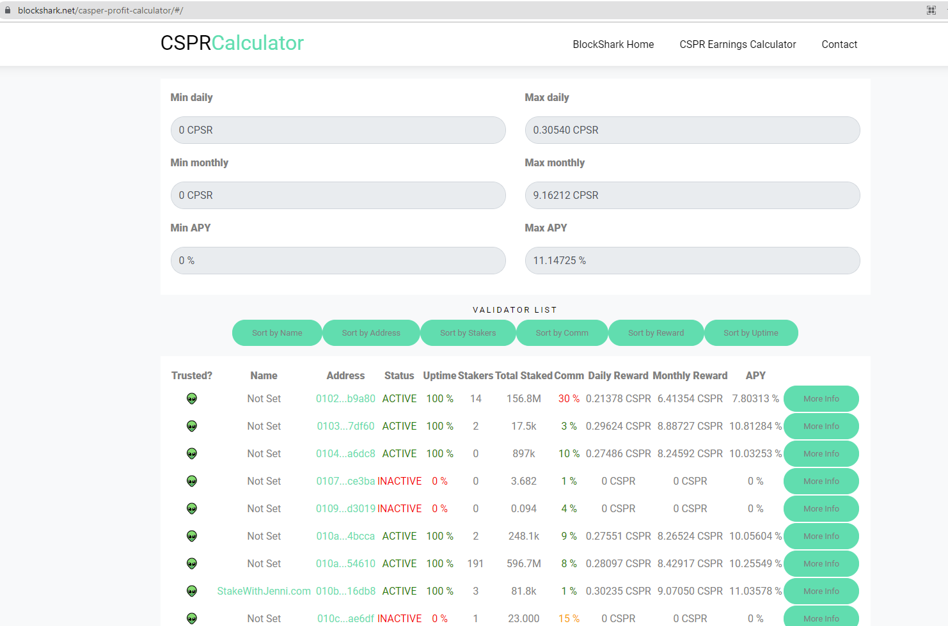

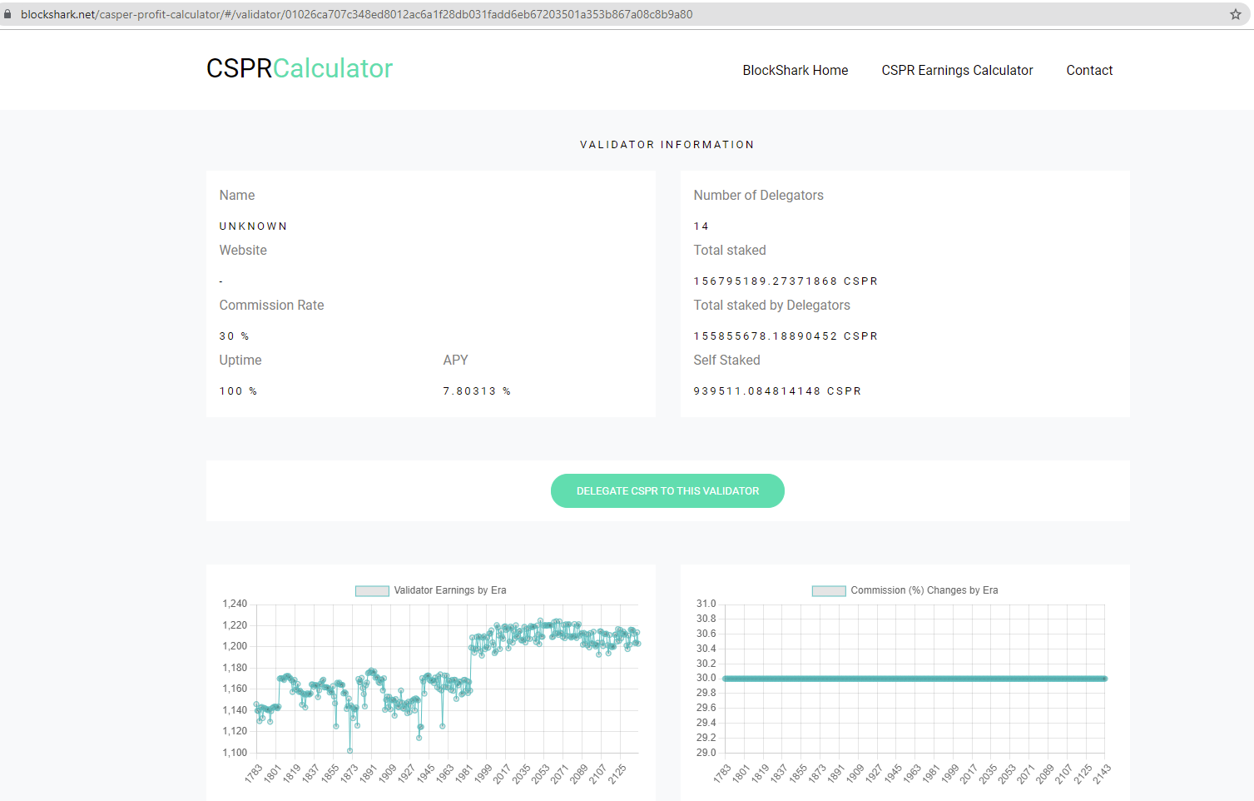

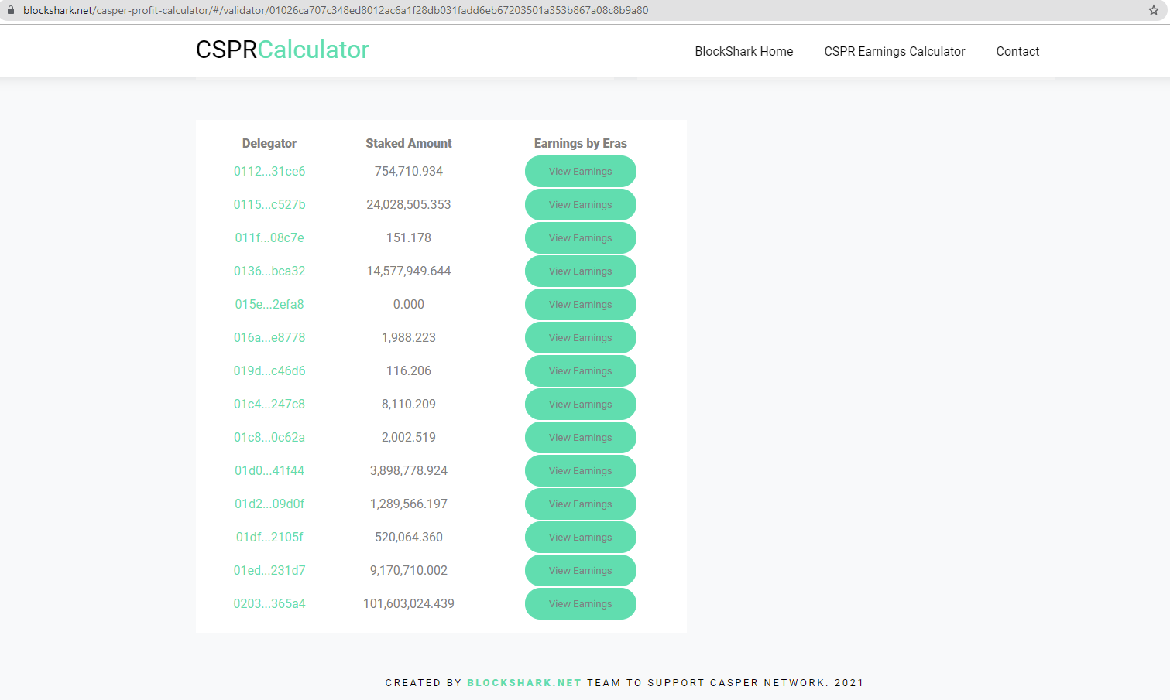

* How to run:
  + Installing the mongodb
  + Installing the nodejs
  + Clone our code from github
  + Go to root folder (For api and for app client)
  + For client site, if you want to start on localhost, lets update this config:

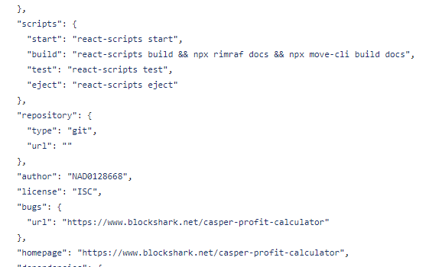

* + - Change “homepage” to “<http://localhost:3000/>”
    - If you want to start with SSL, lets create your ssl before run this app.
  + Run command:
    - $ npm install
  + For the api, you can run this command to start api:
    - $ node casper-api.js
    - $ node casper-cron.js
  + For the client site, you can run this command to start application:
    - Go to the root folder of project
    - $ npm start
  + After that, you can use go to this link on browser:
    - <http://localhost:3000>
    - 